General Rally Information
Directions
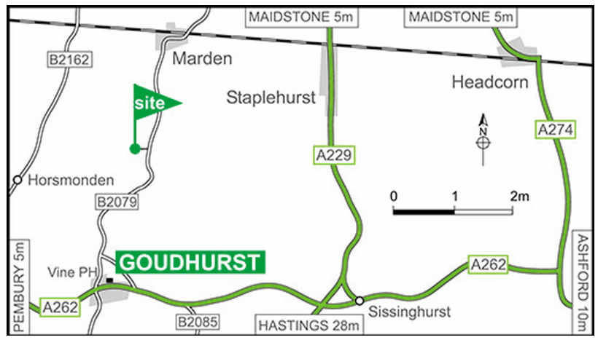
Please use sat nav with caution. Turn off the A262 in Goudhurst by The Vine Inn onto the B2079 (signposted Marden, international caravan site sign). The Site entrance is on the left within 3 miles (see streetview & map). From the North (Maidstone) on the A229: in 1.25 miles fork right at the roundabout onto the A229 towards Loose, Coxheath; in 4 miles just past Stile Bridge Inn, fork right onto the B2079 to Marden; in 2.25 miles at the T-junction in Marden turn right (still on the B2079). The Site entrance is on the right within 2.5 miles (see streetview & map). From the East on the A262: on entering Goudhurst fork right by The Goudhurst Inn onto the B2084; in about 0.75 mile turn right onto the B2079; then as above.
Postcode: TN12 9ND
GPS: Lat 51.14751 / Lon 0.47578
OS grid ref: TQ731417
OS Landranger (1:50,000) map 188
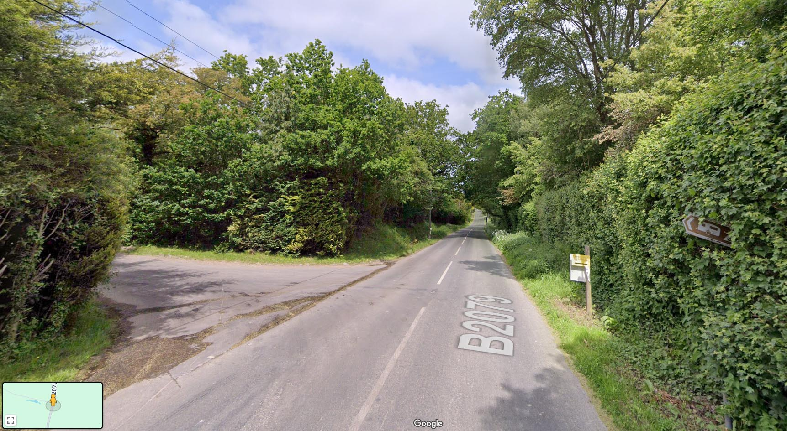
Streetview of B2027 looking North at entrance to Tanner Farm Park

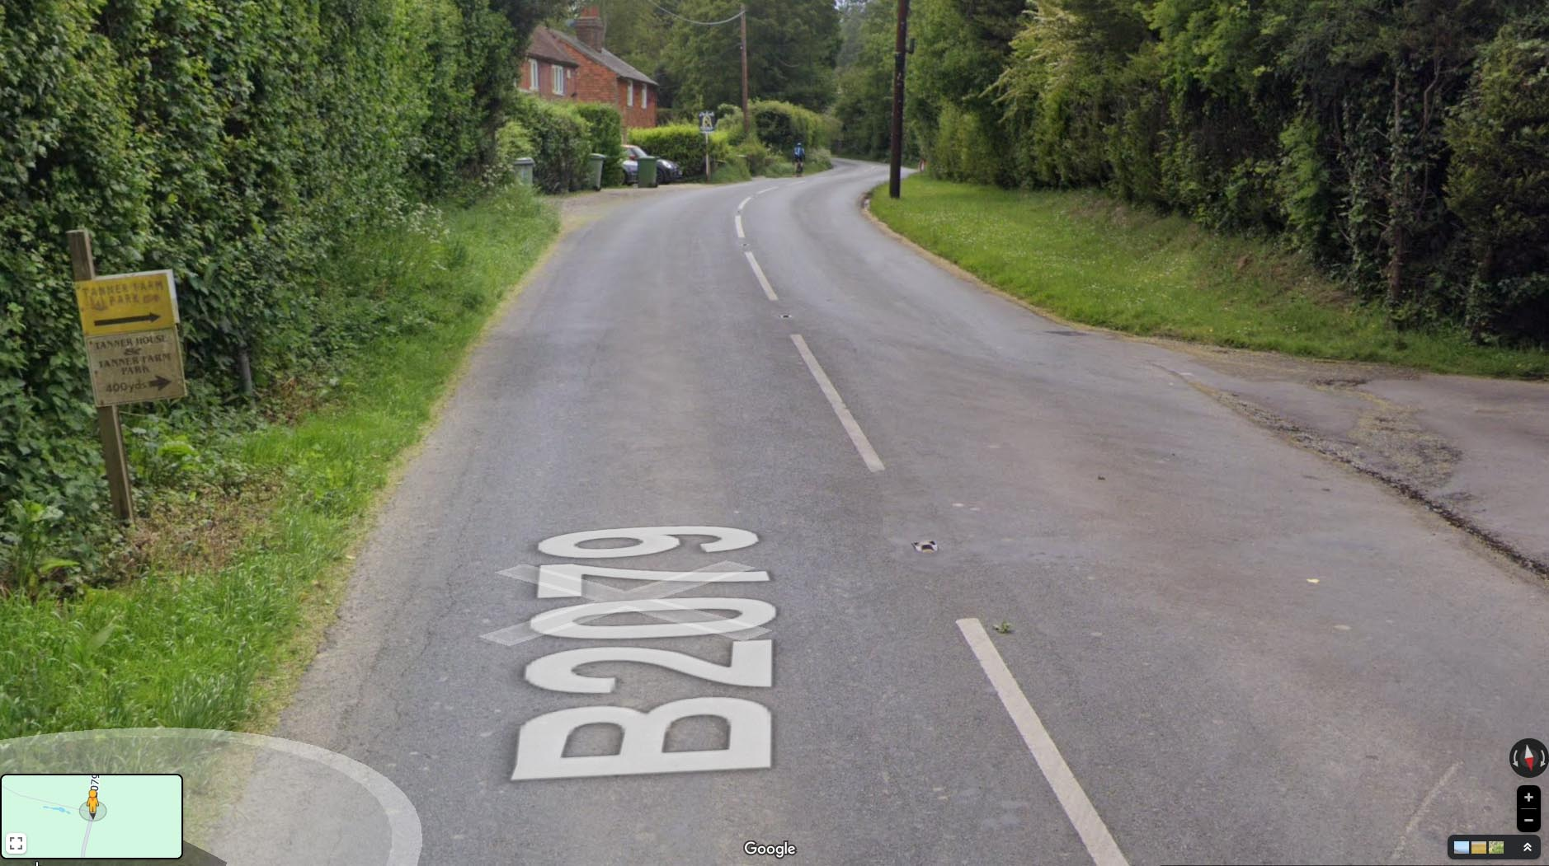
Streetview of B2027 looking South at entrance to Tanner Farm Park

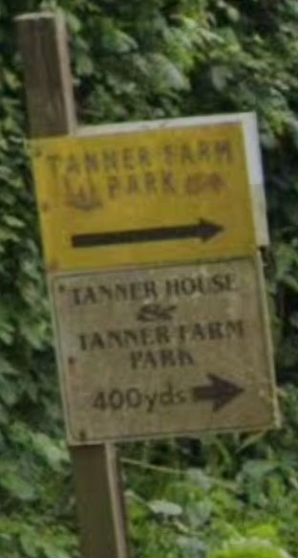
Close-up of the sign for Tanner Farm Park

Arrival
You may arrive at the site from 08.30 from Friday 23rd May to the end of the rally. When you arrive, please go to the campsite reception to register and be directed to a pitch. Badges and t-shirts, if ordered, will be available for collection from the marquee.
You will also be offered the opportunity to book a slot for the fish and chips evening and to order your meat for the BBQ. You can still order later if you wish.
Departure
Please leave the campsite by 12.00. If you wish to stay longer please check with reception before 10.30am on your day of departure.
Visitors
There may be a small charge for those staying offsite and visiting the site during the day or evening. This has not been confirmed by the site as yet.
Electric Charging for cycles and sundry items
All those on a numbered pitch will be able to charge their cycles and sundry equipment from their hook-up. Cars must not be charged from the campsite hook-ups. Cycle campers will have access to charging points in the marquee.
WiFi
The telephone signal is very poor around the site. The site have had a third party WIFI system installed by TSG WIFI. It is not cheap but it will save you pulling your hair out. You can connect 10 devices to each login.
1 day | £6
3 days | £10
4 days | £12
7 days | £15
14 days | £25

Fridge/Freezers
In the marquee there will be a fridge for the use of cycle campers. The campsite has also made available their freezer, located in the Information Room, for the use of rally attendees. This can be used for storing bagged, labelled frozen food.
Shopping
Noting the site is quite remote and a number of the rides do not pass close to shops on their return to the site, the site has a well stocked shop that generally sells Gas, Aqua Kem, milk, soft drinks, bread, eggs, local Korker sausages, a selection of groceries, ice creams and caravan accessories. Newspapers and magazines can be ordered. The campsite is card only payments.
The Campsite have arranged a daily delivery from Sainsbury’s, starting from Monday 26th. Orders should be placed with Reception by 1600 hrs on the previous day There will be a list of groceries from which we can select but if you require other items, you will need to supply the Sainsbury code and price. Card payments only and please note there will be a small mark-up to cover the site’s costs. Cold groceries will be kept refrigerated until collection.

The site also has an arrangement with The Bread Shed who provide sandwiches, scotch eggs and salad pots. These are available from the fridge in Reception.

Local Shops
The closest small shops are in Marden:

Cost Cutter Convenience stores & Post Office | High Street | Marden
Nisa Local Marden Stores | Church Grn | Marden
Stanleys at Albion Garage (petrol, calor and DIY) | Albion Road | Marden
Butcher (Ken Ballard, closed Monday) | Churn Grn | Marden

Large Supermarkets

Sainsbury’s | Staplehurst | 6 miles
Tesco | Paddock Wood | 8 miles
Waitrose | Paddock Wood | 8 miles

Many more in Tunbridge Wells and Tonbridge.

Cycle shops

Larkfield Cycles | 8 Martin Square, Larkfield, Aylesford ME20 6QJ | 01732 847438 | Bikes clothing, accessories, components | 15 miles
Senacre Cycles | 8-9 Senacre Square Maidstone ME15 8QF | 01622 752695 | Bikes, parts, accessories, servicing | 10 miles
Cycle-Ops | 8 Bank Street, Tonbridge TN9 1BL | 01732 500534 | Bikes, parts, clothing & accessories | 15 miles
Cycles UK | 21-25 Lower Stone Street, Maidstone ME15 6YT | 01622 688162 | Bikes, parts, clothing & accessories | 10 miles
UK Electric Bike Centre | Headcorn Aerodrome, Shenley Road, Headcorn, Ashford TN27 9HX | 01622 890300 / 07904 287485 | Bikes, bike hire, service & repairs | 12 miles
Mission Cycles Ltd | Unit 3, The Alders, Seven Mile Lane, Mereworth, Maidstone ME18 5JG | 01622 815678 | Trikes and accessories | 13 miles
Velocipede Cycles | 122-124 Camden Road, Tunbridge Wells TN1 2QZ | 01892 512120 | Bikes, e-bikes, workshop, parts & accessories | 14 miles
Wildside Cycles | 77-83 Camden Road, Tunbidge Wells TN1 2QL | 01892 527069 | Bikes, clothing & accessories | 14 miles
RM Cycles | Unit 3A Leigh Green Industrial Estate, Appledore Road, Tenterden TN30 7DE | 01580 765612 | Bikes, parts, tools, accessories & workshop | 17 miles
Giant Paddock Wood | 62-62a Maidstone Road Paddock Wood, TN12 6AF | 01892 832823 | Bikes, parts, accessories, clothing | 8 miles
Halfords | Cannon Lane Tonbridge , TN9 1PN | 01732 770741 |  | 16 miles
Halfords | Unit 6 Aylesford Retail Park, Mills Road, Maidstone ME20 7TP | 01622 715333 |  | 13 miles

Organised events:
As there are no reasonably accessible local pubs we are setting up a bar in the marquee. The bar will be open each evening and we will organise the opening times to generally fit with peoples needs. The bar will be run on a largely non-profit basis and payment will be via a card reader. There will be local keg beer and cider, wine and a selection of soft drinks.
Please remember to bring your own glass.

Sat 24 May | 1900 | Welcome Evening in the marquee. | Drinks and nibbles, remember to bring a glass
Sun 25 May | 1700 | Tandem Games | Traditional set of Tandem Games
Sun 25 May | 19:30 | Bike Jumble Sale
Mon 26 May | 1930 | Talk on The Hop Bine & the hop pickers of Kent | The History, Growing, Harvesting and Uses of the Hop by Chris Stewart
Tues 27 May | 1930 | Quiz Night | Quiz Master - Lucy
Weds 28 May | 1830 | BBQ | Bring your own food. To save transporting lots of supplies please use the Sainsburys order process. We have also arranged an advance order process from Ken Ballard, Marden butcher, via campsite Reception. NB: there will be no chicken available. Payment will be made to the campsite (card only) at the time of collection with a small mark up. Barbecues and charcoal provided with a separate one for vegetarians.  Entertainment by John and Di Cullen, a guitarist and a singer. The songs are largely humorous
Thurs 29 May | 0900 | Treasure Hunt | Untimed section to the coffee stop at Paddock Wood Community Centre, timed section from coffee to end. Approx 30 miles in total
Thurs 29 May | 1000 – 1300 | Group Coffee Stop | Paddock Wood Community Centre. Coffee and cake provided.
Thurs 29 May | 1000 – 1300 | Try a Tandem Event | Paddock Wood Community Centre
Thurs 29 May | 17:30 | Fish & Chip van on site | To avoid queues these will be pre-ordered. Time slots and food order can be booked at Campsite Reception from Saturday. Payments direct to van on collection, cash or card.
Thurs 29 May | 1930 | Talk: Snails Around France | Retired couple John and Kate Bosley had a dream: to cycle all the way around France on their tandem bicycle. In the summer of 2023, they made that dream a reality, setting out on an epic 12-week, 7,500 kilometre journey that would test their endurance, strengthen their bond, and open their eyes to the wonders of France. Pedalling at a comfortable ‘snail’s pace,’ John and Kate wind their way around the perimeter of France, sticking as close to the borders as possible. From the Channel to the Atlantic to the Mediterranean to the Alps, they experience France’s diverse beauty and culture up close. Along the way, they battle broken spokes, torrential rains, wrong turns, and leg-burning ascents. Through it all, the Bosleys maintain their sense of humour, curiosity and ‘joie de vivre.’ With self-deprecating wit and keen observations, John chronicles their highs, lows, and serendipitous encounters. Kate, visually impaired from a past accident, provides inspiration through her courage and determination.
Fri 30 May | 1900 | Barn Dance | Appropriately named duo 'Two in Tandem', the caller is Chris Woodward

Suggested Rest Day Activities
No organised trips but any of the following would be enjoyable:

Leeds Castle | https://leeds-castle.com/ At 12.3 miles away, this is a good distance for a rest day. Entry is £31.50 (adult online) but it is an impressive place and has plenty of activities for children. Cycle route available for download from ‘Rides’ Section.
Balfours Vineyard | https://balfourwinery.com/visit/eat-with-us/ Tours and tasting, restaurants, shop.
Sissinghurst Castle | https://www.nationaltrust.org.uk/visit/kent/sissinghurst-castle-garden National Trust. Cycle route can be downloaded from ‘Rides’ section.
Scotney Castle | https://www.nationaltrust.org.uk/visit/kent/scotney-castle National Trust
Igtham Mote | https://www.nationaltrust.org.uk/visit/kent/ightham-mote 14th century manor house. National Trust
Bedgebury Pinetum | https://www.forestryengland.uk/bedgebury National pinetum and forest, children’s activities.
Bewl Water | https://aquapark.bewlwater.co.uk/ children’s activities
Tunbridge Wells | https://visittunbridgewells.com/
High Rocks | https://highrocks.co.uk/attractions/the-high-rocks.php Acres of breathtaking sandstone rocks interlinked with eleven bridges, provide a scenic walk in a tranquil woodland setting. Once a stone age camp, now a National Monument these impressive rocks, which belong to The High Rocks complex, have always been a constant source of wonder. Occasionally closed to the public, so phone prior to visiting: (01892) 515532
Spa Valley Railway | https://www.spavalleyrailway.co.uk/calendar.php Check the website for opening.
Aylesford Priory | https://www.thefriars.org.uk/Attractions Medieval buildings, gardens, pottery and duck pond.
Belmont House | https://belmont-house.org/ 18th Century house and gardens
Big Cat Sanctuary | https://thebigcatsanctuary.org/

EMERGENCY CONTACTS

DOCTOR | Marden Medical Centre Church Green Marden TN12 9HP | 6 miles | 01622 831257
HOSPITAL | Maidstone Hospital Hermitage Lane ME16 9QQ | 11 miles | 01622 729000
HOSPITAL | Tunbridge Wells Hospital Tonbridge Road Pembury TN2 4QJ | 12 miles | 01892 823535
DENTIST | Marden Dental & Implant Centre Church Green Marden TN12 9HR | 3 miles | 01622 831556 | (inc out of hours)
DENTAL EMERGENCIES | Dentaline Chatham ME10 2NT | 23 miles | 01634 890300
VET | Goudhurst Vets Bedgebury Road TN17 2QT | 4 miles | 01580 211981
VET | Pattenden Vets Segro House Pattenden Lane Marden TN12 9QJ |  | 01622 397900 | Out of hours: 01622 734054
TAXI | MTC Staplehurst |  | 01622 890003
TAXI | Richard’s Private Car Hire Marden |  | 01622 832252
TAXI | Mayday Minicabs Goudhurst |  | 01580 211175
CARAVAN REPAIRS | Caravan Tech |  | 01580 860260
CARAVAN REPAIRS | Invicta |  | 01622 831346
CARAVAN REPAIRS | Collier Street Caravans |  | 01892 730879 | or 07565 682750

Rides

The rides have all been derived from our monthly Kent area group rides so we know them well and they generally follow the the local back lanes so are quiet and scenic. The cafes in the area are generally small so to avoid them being too busy we have suggested two directions each day. These have been selected on when certain attractions may be open. Of course you can choose to go on any ride on any day as you wish.

Sunday | N or E | Avoid Rye or TW on a Sunday
Monday | S or NW | Animal Farm or Rye
Tuesday | W or NE | Tonbridge Wells
Wednesday | Rest day
Thursday | Velocio
Friday | W or any | High Rocks closed Mon & Tues

List of OS Landranger maps for the Tandem Club National Rally 2025

188; 189; 177 (very limited part of NE long)
178 (NE long, E long & E medium (very limited part))
199 (South long, medium plus & medium)

Direction | Length | ID | Day | Miles | Feet ^ | Maps  (L = only  briefly uses) | Summary
North | Short | 1331 | Sunday | 28 | 650 | 188 | Yalding and Medway
North | Medium | 1332 | Sunday | 51 | 1525 | 188 | Yalding, Medway, Pilgrim’s Way & the Malling district
North | Long | 1333 | Sunday | 56.5 | 2100 | 188 | Yalding, Medway & the Malling district
North East | Short | 1334 | Tuesday | 34.1 | 1325 | 188 | Aylesford Priory
North East | Medium | 1335 | Tuesday | 46.7 | 1475 | 188 189 | Pilgrim’s Way & Aylesford Priory
North East | Long | 1336 | Tuesday | 75.2 | 3025 | 188 189 177L 178 | Pilgrim’s Way, Cyclopark & Aylesford Priory
East | Short | 1337 | Sunday | 36.1 | 950 | 188 189 | Lenham
East | Short Plus | 1338 | Sunday | 41.4 | 1475 | 188 189 | Lenham & North Downs
East | Medium | 1339 | Sunday | 48.5 | 2150 | 188 189 178L | Lenham, North Downs & Belmont House
East | Long | 1340 | Sunday | 57.5 | 2825 | 188 189 178 | enham, North Downs, Belmont House & Favesham
South | Short | 1341 | Monday | 29.8 | 1325 | 188 189 | Tenterden
South | Medium | 1342 | Monday | 45 | 2550 | 188 189 1999 | East Sussex & Tenterden
South | Medium Plus | 1343 | Monday | 51.6 | 2950 | 188 189 199 | Rye & Tenterden
South | Long | 1344 | Monday | 68.5 | 4200 | 188 189 199 | Bodiam, Battle, Rye & Tenterden
West | Short | 1345 | Tuesday | 31.8 | 1900 | 188 | Bewl Water & Tunbridge Wells
West | Short Plus | 1346 | Tuesday | 33.9 | 2175 | 188 | Bewl Water, Wadhurst & Tunbridge Wells
West | Medium | 1347 | Tuesday | 28.7 | 2625 | 188 | Bewl water, Wadhurst, Groombridge & Tunbridge Wells
West | Long | 1348 | Tuesday | 63 | 4575 | 188 189 | Bewl water, Wadhurst, Brightling Down, Groombridge & Tunbridge Wells
North West | Short | 1349 | Monday | 26.8 | 1375 | 188 | Aspens Animal Farm and cafe
North West | Medium | 1350 | Monday | 40.6 | 2025 | 188 | Tonbridge & Igtham Mote
North West | Long | 1351 | Monday | 60.9 | 3175 | 188 | Tonbridge, Chiddingstone & Igtham Mote
Sissinghurst Castle loop | Short | 1352 | Any | 16.3 | 600 | 188 | Sissinghurst Castle
Leeds Castle loop | Short | 1353 | Any | 30.3 | 1000 | 188 189 | Leeds Castle
Leeds Castle direct | Short | 1354 | Any | 12.4 | 500 | 188 | Leeds Castle
Bedgebury Pinetum direct | Short | 1355 | Any | 6.8 | 725 | 188 | Bedgebury Pinetum
Bewl Water and Scotney Castle loop | Short | 1356 | Any | 20.2 | 1800 | 188 | Bewl Water and Scotney Castle
North West shorter Medium | Short Plus | 1594 | Monday | 31.9 | 1475 | 188 | Aspens Animal Farm and cafe and Medway Valley

